- Full code file (please drag and drop to explorer to make a copy):
- Github link.
- Screenshots:
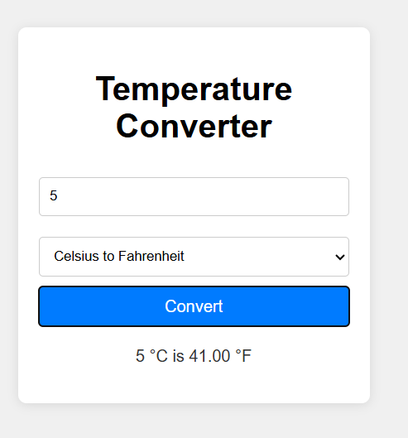
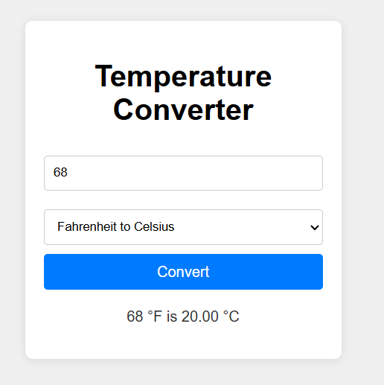
- Code:
<!DOCTYPE html>
<html lang="en">
<head>
<meta charset="UTF-8">
<meta name="viewport" content="width=device-width, initial-scale=1.0">
<title>Temperature Converter</title>
<style>
body {
font-family: Arial, sans-serif;
display: flex;
justify-content: center;
align-items: center;
height: 100vh;
background-color: #f0f0f0;
margin: 0;
}
.converter {
background-color: white;
padding: 20px;
border-radius: 8px;
box-shadow: 0 2px 10px rgba(0, 0, 0, 0.1);
width: 300px;
text-align: center;
}
input[type="number"] {
width: 100%;
padding: 10px;
margin: 10px 0;
border: 1px solid #ccc;
border-radius: 4px;
box-sizing: border-box;
}
select {
width: 100%;
padding: 10px;
margin: 10px 0;
border: 1px solid #ccc;
border-radius: 4px;
box-sizing: border-box;
}
button {
width: 100%;
padding: 10px;
background-color: #007bff;
color: white;
border: none;
border-radius: 4px;
cursor: pointer;
font-size: 16px;
}
button:hover {
background-color: #0056b3;
}
#result {
margin-top: 20px;
font-size: 16px;
color: #333;
}
</style>
</head>
<body>
<div class="converter">
<h1>Temperature Converter</h1>
<input type="number" id="temperature" placeholder="Enter temperature">
<select id="conversionType">
<option value="cToF">Celsius to Fahrenheit</option>
<option value="fToC">Fahrenheit to Celsius</option>
</select>
<button id="convertBtn">Convert</button>
<p id="result"></p>
</div>

<script>
// Function to convert Celsius to Fahrenheit
function celsiusToFahrenheit(c) {
return (c * 9 / 5) + 32;
}

// Function to convert Fahrenheit to Celsius
function fahrenheitToCelsius(f) {
return (f - 32) * 5 / 9;
}

// Event listener for the convert button
document.getElementById('convertBtn').addEventListener('click', function() {
const input = document.getElementById('temperature').value;
const conversionType = document.getElementById('conversionType').value;
const resultElement = document.getElementById('result');

// Validate input using control structures
if (input === '' || isNaN(input)) {
resultElement.textContent = 'Error: Please enter a valid numeric temperature.';
resultElement.style.color = 'red';
return;
}

const temp = parseFloat(input);
let result;

// Perform conversion based on selected type
if (conversionType === 'cToF') {
result = celsiusToFahrenheit(temp).toFixed(2);
resultElement.textContent = `${temp} °C is ${result} °F`;
} else if (conversionType === 'fToC') {
result = fahrenheitToCelsius(temp).toFixed(2);
resultElement.textContent = `${temp} °F is ${result} °C`;
}

resultElement.style.color = '#333';
});
</script>
</body>
</html>

